AGI Westeel Roof Tool – Canada – Instructions and Training
Getting Started:
The purpose of this tool is to ensure that all AGI Westeel Bins being ordered from the Price Pages, are being ordered and built with the proper roof upgrades, dependent on the location of the bin given by the customer. All the inputs and results for this tool are located on the Main tab. Be conscience of your inputs, ensuring that you are inputting the correct information, as wrong information will lead to incorrect results.
How to Use:
Step One: If a yellow bar with a button saying, “Enable Content”, appears at the top of the Excel screen upon opening the tool, push the button to “Enable Content”. If you do not push this button, you will not be able to fill in any of the necessary fields. Once you have enabled the content, fill in the Customer Name, PO Number, and AGI Westeel Sales Order Number, in the top right, if applicable. This information will be used to easily keep track of orders.
Step Two: Start designing your bin! The tool is easy to follow, simply start at the top section and work your way down filling in all the mandatory sections. All mandartory sections are marked with red stars (*). Each drop-down list is dependent on the one before it. Therefore, you must work from the top section down. If you try to fill in the drop-down lists out of order, they will appear blank until the ones above it are filled in. For sections with drop-down lists, simply click on the drop-down arrow and select the proper option. For sections needing manual inputs, ensure to double check that you typed your input in correctly.
Section Overviews:
Section One: Location Usage
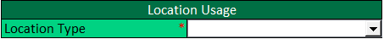
This section is used to determine the usage of your bin. You will have two choices from the drop-down list; Farm (Price List) and Commercial. If you choose Farm (Price List), you can continue onto the next section. If you choose Commercial, you will not be able to update any drop-down lists or input cells, and a notification will appear in yellow, in the results section, asking you to “Please contact AGI Westeel Customer Service about seismic considerations.” We ask you to please contact AGI Westeel Customer Service as your bin may need seismic upgrades, which this tool is not capable of.

Section Two: Bin Requirements
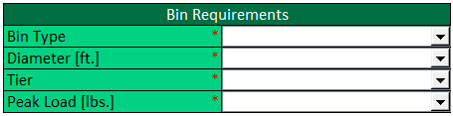
This section is used to determine the type, size, and peak load rating of your bin. In the Bin Type drop-down list, you will have seven choices; Unstiffened AGI Westeel Flat Bottom, Stiffened AGI Westeel Flat Bottom, AGI Westeel EasyDry SGL Fan Inlet, AGI Westeel EasyDry DBL Fan Inlet, Unstiffened AGI Westeel Hopper, Stiffened AGI Westeel Hopper, or Stiffened AGI Westeel SSK. The Diameter [ft.] drop-down list will have different choices, ranging from 15’ to 60’, depending on the Bin Type you chose. Just like the Diameter [ft.] drop-down list, the Tier drop-down list will have different choices, ranging from 3 to 16, depending on the combination of Bin Type and Diameter [ft.] you chose. Finally, in the Peak Load [lbs.] drop-down list you will have three options; Standard, Higher Rated, and Unknown. Most bins will only need the Standard peak load, but some roofs with applications like, catwalks, downspouts, etc., will need the Higher Rated peak load. To the right of the input sections, there is a table with the maximum peak loads for both standard and higher rated based on roof type and roof size. If you are unsure which Peak Load rating your bin will need, you can choose Unknown and the tool will calculate based on the Higher Rated peak load. If you have chosen Unknown, but would like a more precise answer, please contact AGI Westeel Customer Service and we will help you determine which peak load rating is best for your bin.
Section Three: Bin Location
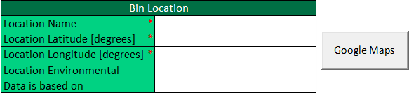
This section consists of all manual inputs. Make sure to double check all your inputs in this section, as errors in the latitude or longitude will change the end results. First you will input the name of the location where your bin is located, in the Location Name cell. Next you will click on the button that says, “Google Maps”, which will automatically open “Google Maps” in your default browser. Once open, put in the address where your bin will be located, and zoom into the exact location of your bin. Once there, hover over the general area with your mouse cursor, and left click. A pin will drop where you clicked, and a small pop-up at the bottom center of your screen will appear showing the latitude (number on the left) and longitude (number on the right) of your chosen location.
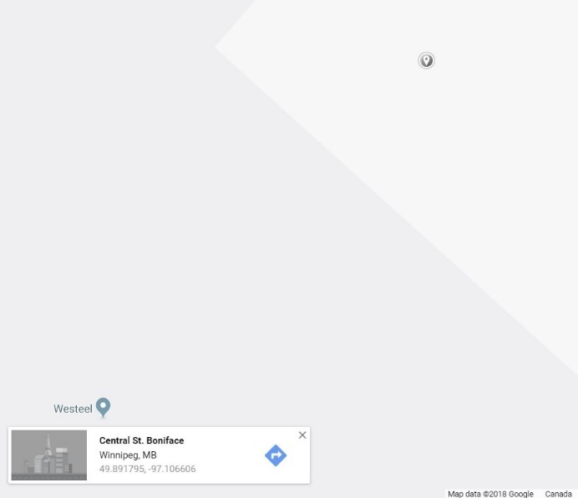
You will then take the numbers for the latitude and longitude and input them into the corresponding cells. (If you left click on your bins location and a pin or pop-up does not appear, you can use another method to get your coordinates. Instead, right click on the location of your bin and a menu will appear where you clicked. Select the “What’s here?” option, then a pin will drop at that location and a pop-up box will appear with the coordinates for that location.)
Once you have input your bin’s location name, latitude, and longitude, the final cell in this section will auto-populate with the town/city that will dictate the environmental data for your bins location. The environmental data for this tool is sourced from NBCC 2015 Volume 1 Division B Appendix C. The tool determines which environmental data to use by taking the coordinates you input and comparing them to the coordinates of all the various locations from the NBCC. It will then choose the nearest location, from its range of towns/cities. It is important to understand that the NBCC does not have environmental data for every location in Canada, and the tool can only use location data from the NBCC. If the location that the tool auto-populates for dictating the environmental data is unfamiliar to you, or you believe there is a location closer, double check the latitude and longitude you input are correct. If you still believe the auto-populated location is incorrect, please contact AGI Westeel Customer Service.
Section Four: Cable Monitoring System
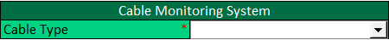
In this section you will input whether your bin will have a Monitoring Cable System or not. If it will have a Monitoring Cable System, you will need to choose which type it will be. The Cable Type drop-down list will present you with three options: None, AGI SureTrack Temp, and AGI SureTrack Moist/Moist & Temp. If you choose None, you are saying your bin will not have any kind of monitoring system in it. Choosing AGI SureTrack Temp, you are saying your bin will have Temperature cables in it. Choosing AGI SureTrack Moist/Moist & Temp, you are saying your bin will have either Moisture cables, or a combination of Temperature and Moisture cables in it. Depending on the Bin Type, Diameter and number of Tiers you chose for your bin, the tool will determine the AGI SureTrack Monitoring Cable System that works with your bin from a set of standard criteria that AGI Westeel has chosen. It is important to understand that these standard criteria are based on AGI SureTrack Standard packages and cable lengths AGI Westeel has determined. The criteria can be found below, and in AGI Westeel Roof Tool – Canada.
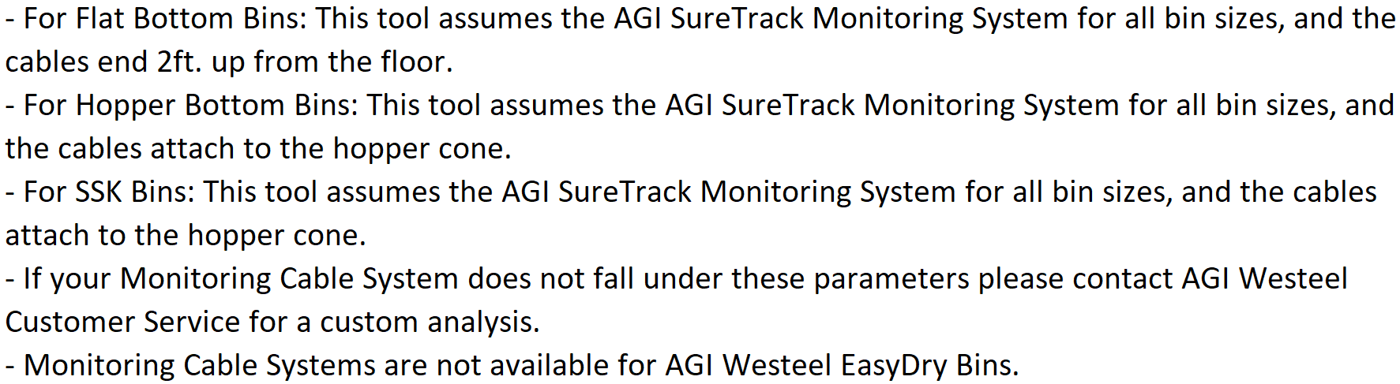
It is important that these standard criteria are followed. If you have purchased a Monitoring Cable System from another company or are reusing an older Monitoring Cable System and are unsure if it follows the above criteria, or you know it does not follow these criteria, please contact AGI Westeel Customer Service.
Section Five: Results
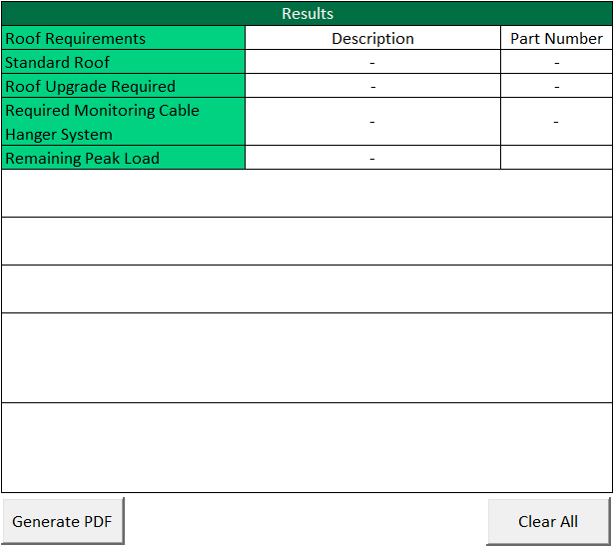
This section will give you the results of all the data you have input into the tool. The Standard Roof output will show you the standard roof for the bin diameter you have chosen. It will give you a description of that roof and its corresponding part number. The Roof Upgrade Required output will show you if there are any mandatory roof upgrades required for your bin. It will give you a description of which roof upgrade you will need, and its corresponding part number, which will be highlighted in green (depending on the bin diameter you have chosen, the number of possible roof upgrades will change). If no roof upgrade is required, the Roof Upgrade Required cells will remain as “-“. The Required Monitoring Cable Hanger System output will show you the required Hanger System your Monitoring Cable System will need to hang from a AGI Westeel roof, based on AGI Westeel assumptions and logic. If your Monitoring Cable System is a AGI SureTrack Standard Package, this output will remain as “-“, as these packages will already include everything you will need to set-up your Monitoring Cable System. If your Monitoring Cable Hanger System is different from the one this tool has stated, please contact AGI Westeel Customer Service for further information. The Remaining Peak Load output will show you the amount of Peak Load you have available. The only factor, within the tool, that will reduce the Peak Load is if you have chosen a cable system that has a central cable.
There are five output sections underneath the roof requirements. These lines will auto-populate under certain conditions. The first section will read, “Structural roof replaces standard roof. You will need to purchase P/N instead of the standard roof”, if the roof requires an upgrade from a non-structural roof to a structural roof. Where P/N is the part number of the diameter specific structural roof.
The second section will highlight in yellow and read, “Please contact AGI Westeel Customer Service about seismic considerations.”, if Commercial has been chosen in the Bin Type drop-down list.
The third section will highlight in yellow and read, “Please contact AGI Westeel Customer Service for potential wind upgrades.”, if the Wind Speed, for the location the environmental data is based on, is larger than 94 mph.
The fourth section will highlight in red and read, “ROOF IS OVERLOADED. Neither the standard roof nor any standard roof upgrades will accommodate the loads. Please contact AGI Westeel Customer Service for potentional further roof upgrades”. If this output appears, neither the standard roof nor any standard roof upgrades are sufficient to accommodate the loads, for the diameter and tier height of bin you have chosen. In this situation, you can contact AGI Westeel Customer Service to see if there is a possibility for further non-standard roof upgrades that will accommodate the loads for your bin. Otherwise, if this output appears, the bin you have designed, in the location you have given, will not work, and cannot be purchased.
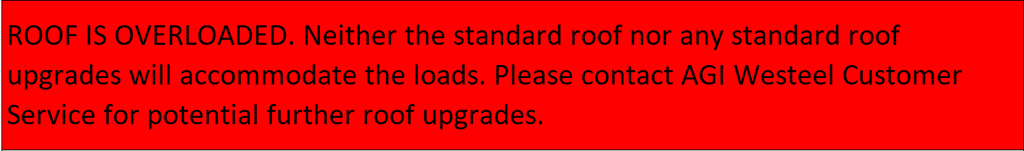
The fifth section will highlight in yellow and read, “Currently AGI Westeel 15’-27’ welded hopper bottoms are manufactured for unstiffened bins only. Please ensure the third-party hopper you are using will work with AGI Westeel products.”, if you have chosen a 15’, 18’, 21’, 24’, 27’, 30’, or 33’ Stiffened AGI Westeel Hopper.
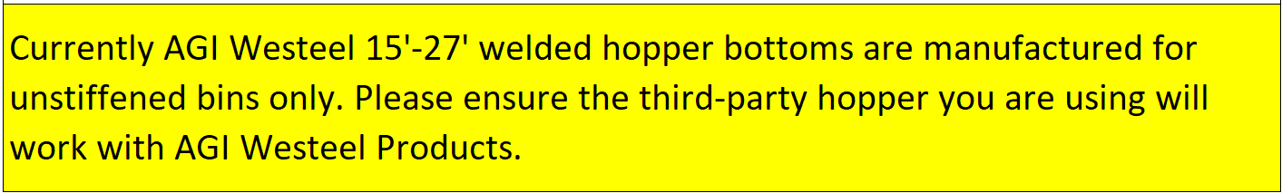
If any of these sections output “Please contact AGI Westeel Customer Service …”, then you must contact AGI Westeel Customer Service to have your situation looked at. If these sections do not say to contact AGI Westeel Customer Service, or do not say that the roof is overloaded, then you can move on to the last step.
Once you have input all the correct data, and reviewed the results, you must generate a PDF of your inputs and results by pressing the “Generate PDF” button. This will automatically save and open a PDF of the AGI Westeel Roof Tool – Canada with all your inputs and results. The PDF will save in the file location “C:\AGI Westeel Roof Tool – Canada – Results”, with a file name based off your inputs in the format of, “Bin Type, Diameter, and Tier – Location Name – AGI Westeel Roof Tool – Canada – Todays Date”. (i.e. Unstiffened AGI Westeel Flat Bottom 3606 – AGI Westeel Storage Yard – AGI Westeel Roof Tool – Canada – 01-25-2022). Before you close the PDF, you may save it to your preferred file location, and add any other description to the file name, for your own records. We ask that you only add to the file name and do not remove anything from the standard naming format.
If you need to reset your input values for any reason, push the “Clear All” button at the bottom of the screen. This will reset all the drop-down lists and input cells to blank.

